OOP Assignment 1
Car Marketplace System

Rabisa Ali (25K-0876)
BCS-2C

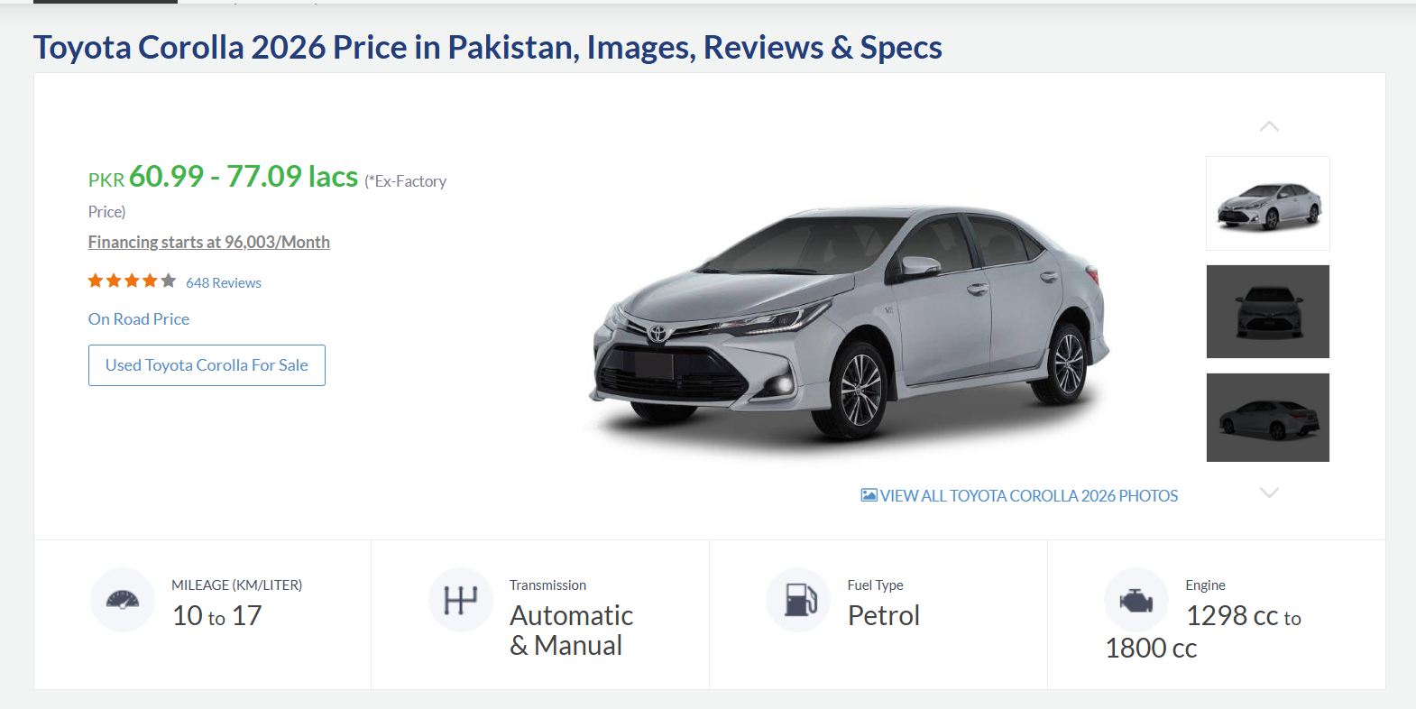
The following car has attributes like price, mileage, model, and brand etc.
This has been implemented in the code by making a class named as Car which has these attributes along with some other attributes.
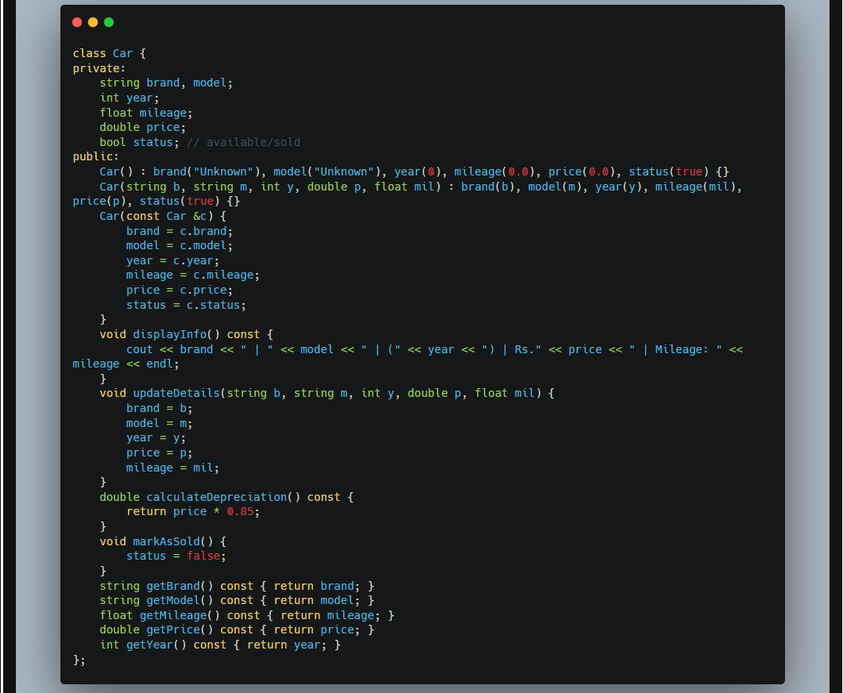
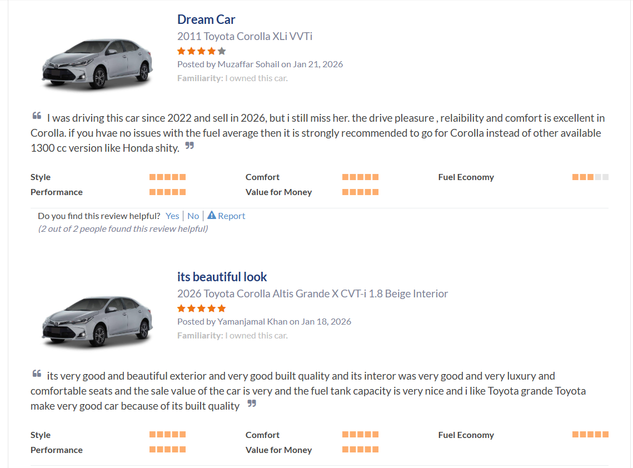
The review system of the PakWheels has been cloned in the code by making up a class named Review which has the attributes of review ID, reviewer ID, seller ID, rating, the comment, and the date of the comment. 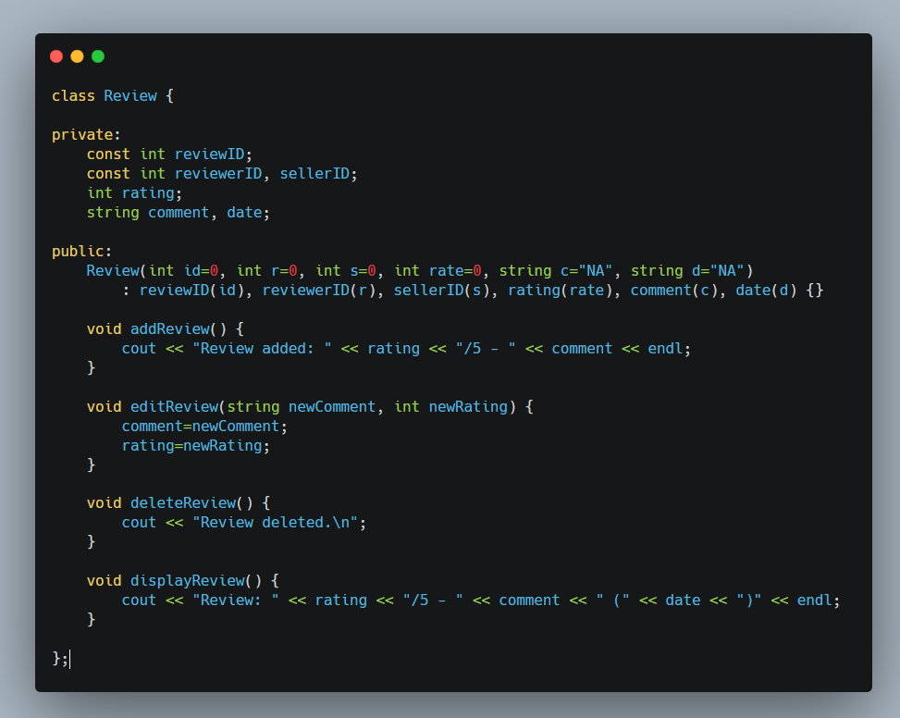

With every Ad that is posted on PakWheels, the seller’s details are displayed including their location, and number.
In order to mimic this in my code, I have made a Seller class with attributes like Seller ID, name, contact, and rating along with the number of cars they have sold and every car’s details and their reviews (composition).

My code snippet:
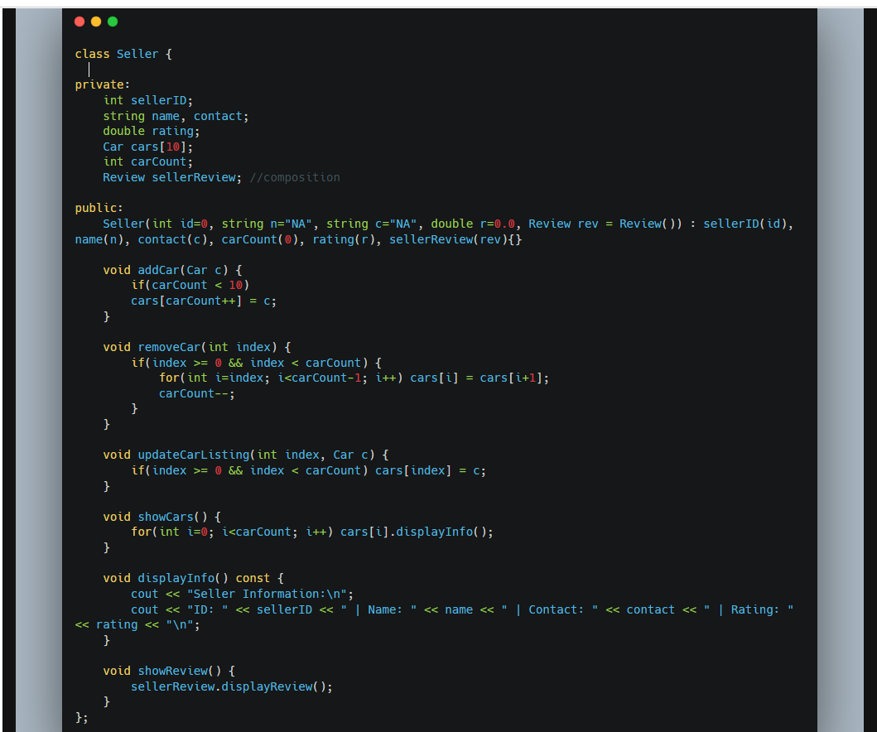

PakWheels also has a marketplace where you can get an overall idea of the services provided by the website and the types of cars sold.
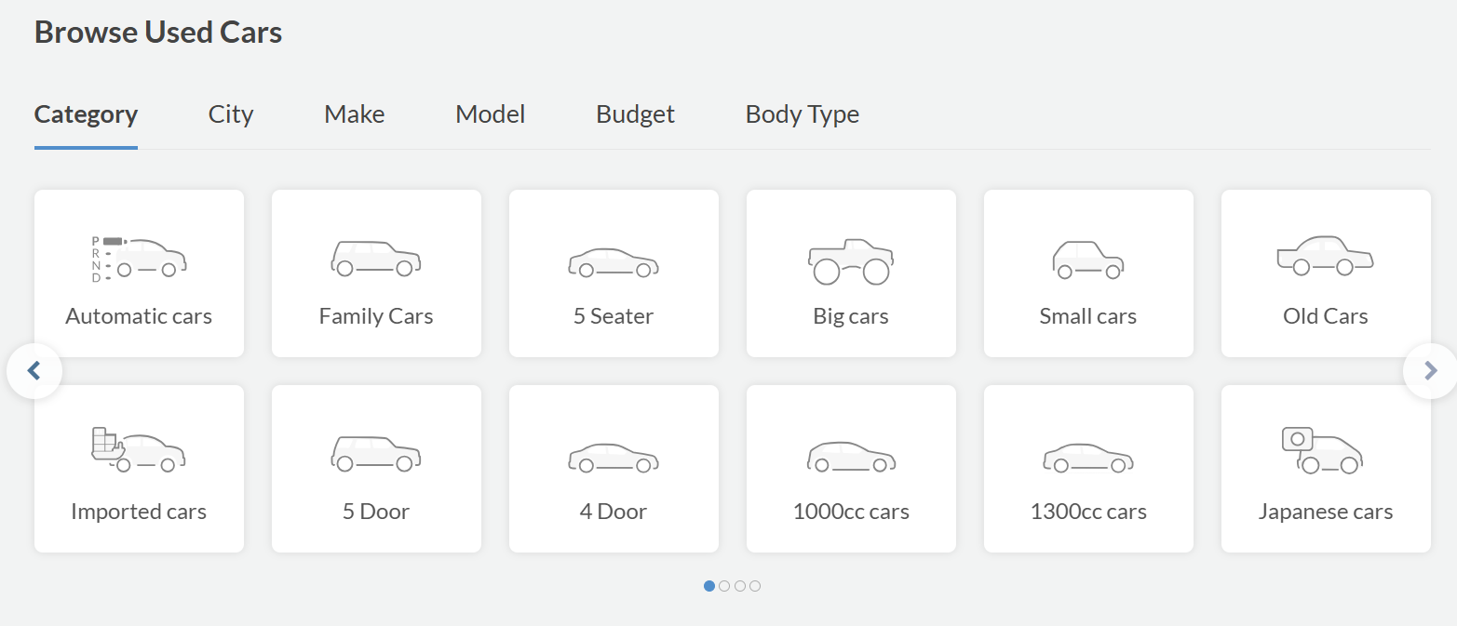
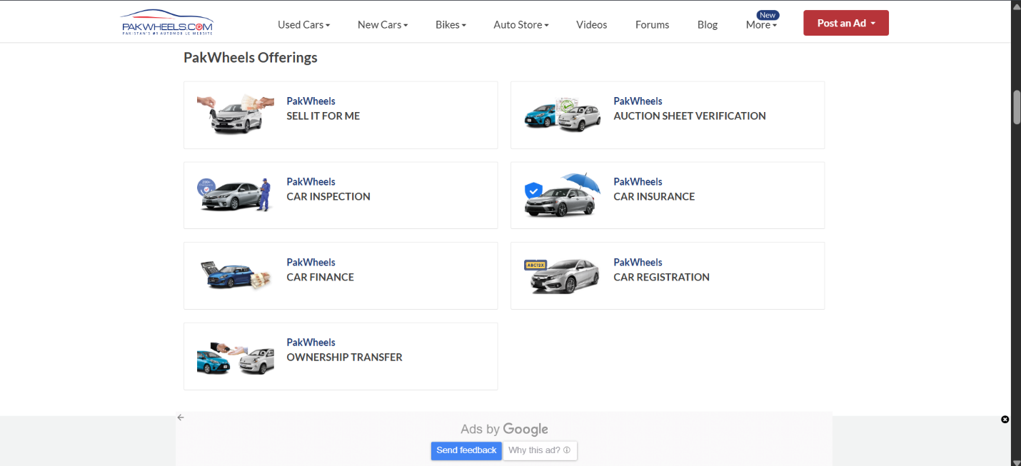

In order to implement this marketplace concept in my code, I created a marketplace class which consisted of a system name, listings of all the things being sold, sellers’ profiles(aggregation) and their count along with total users count (using static data attribute). 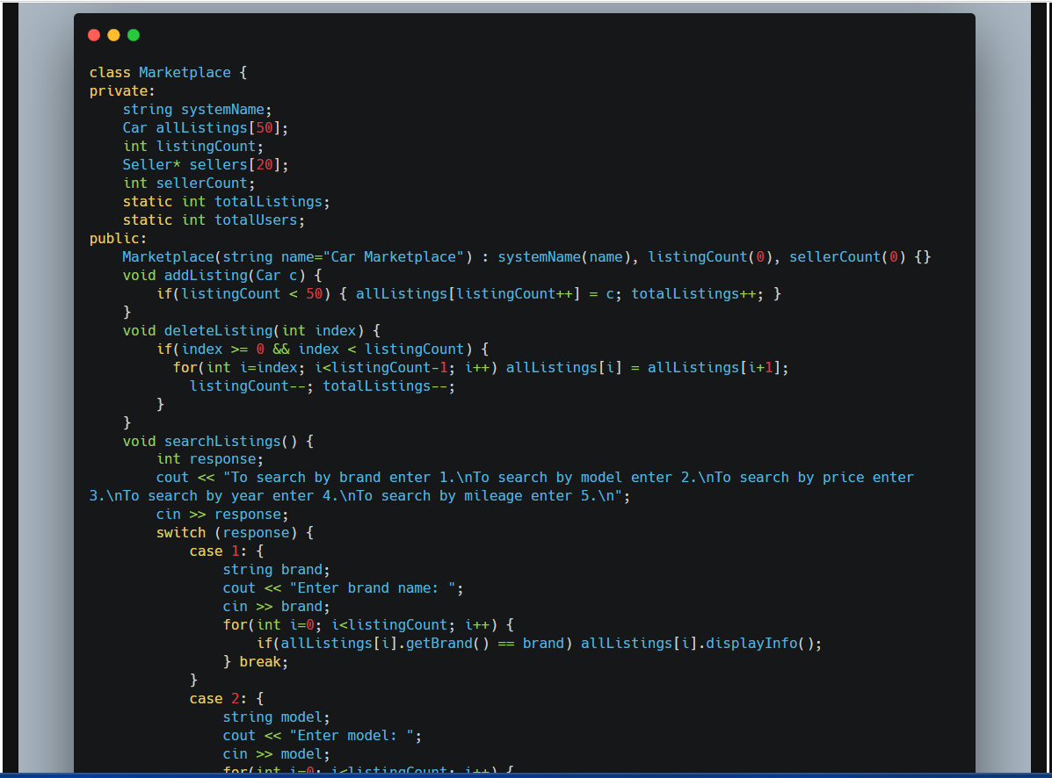
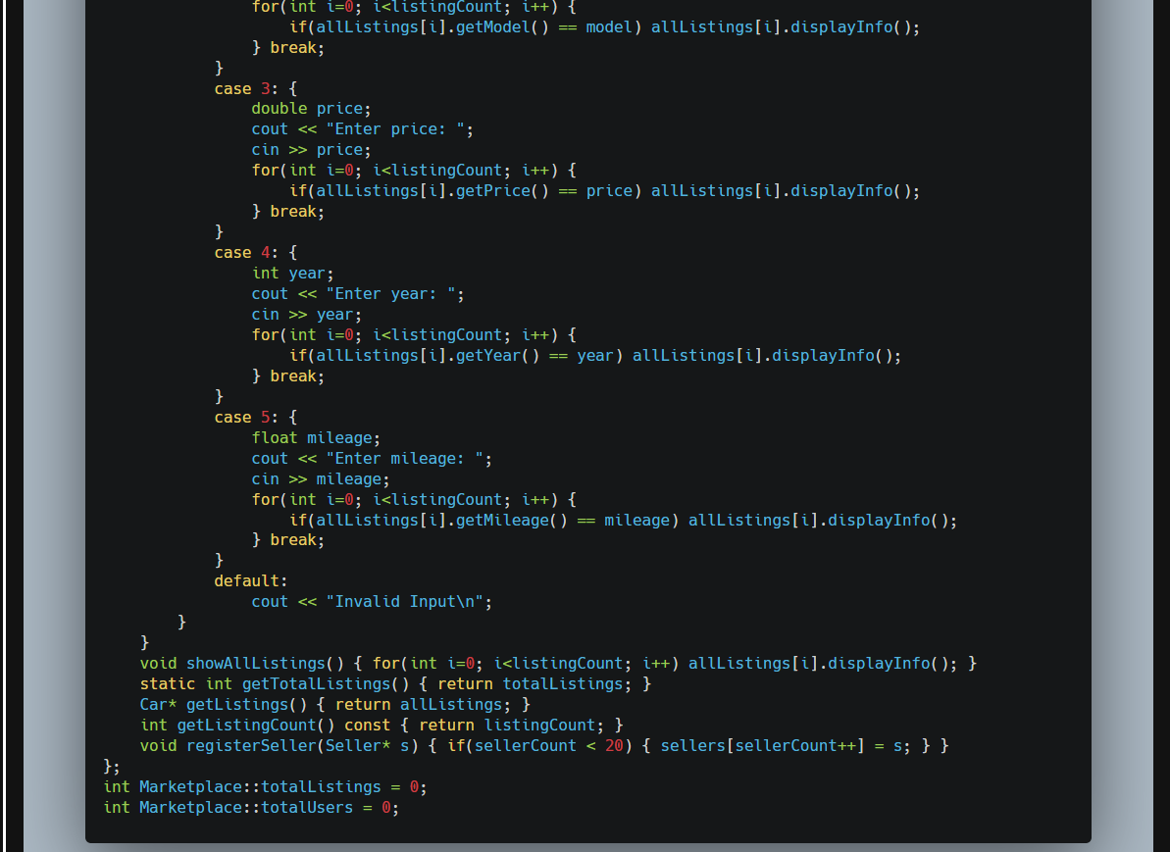

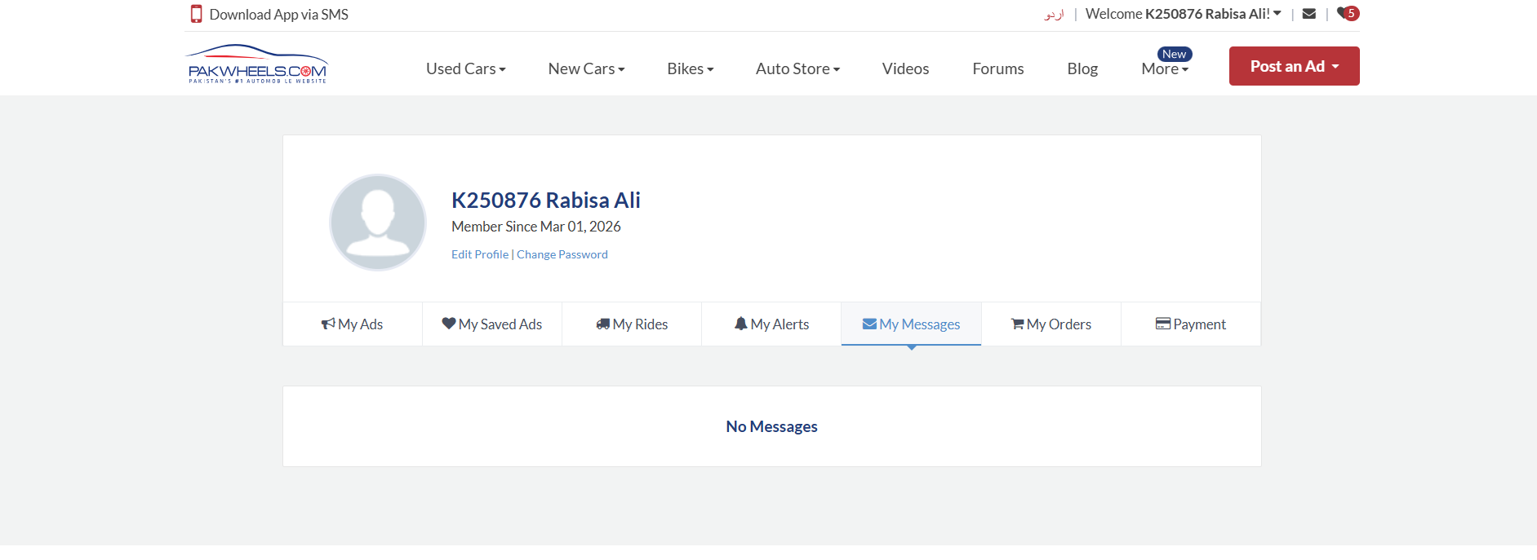
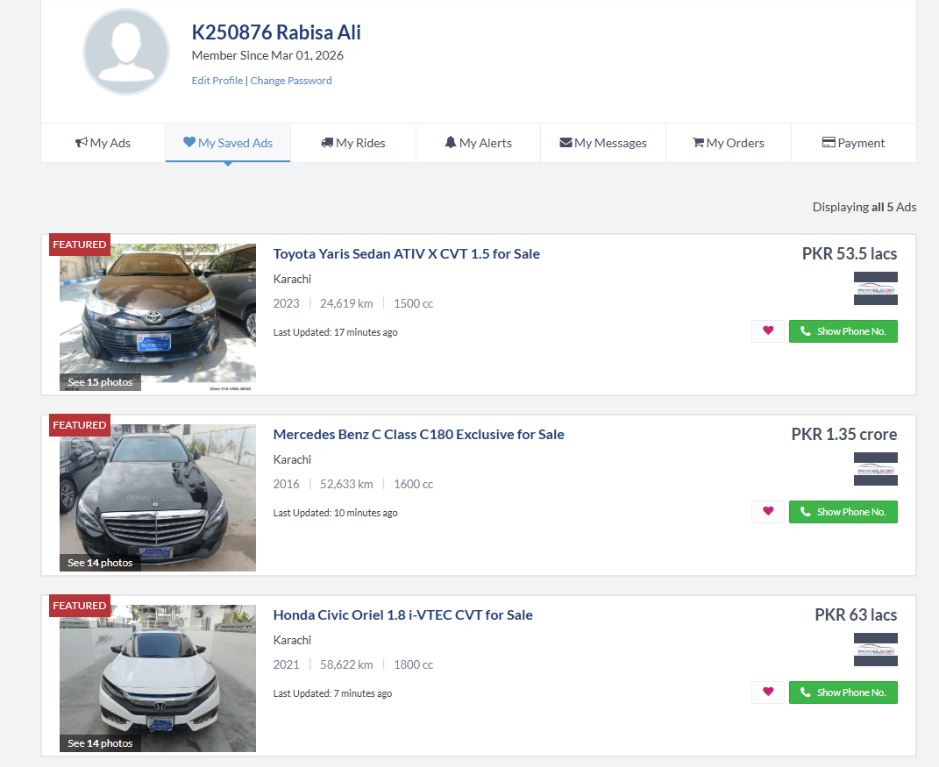

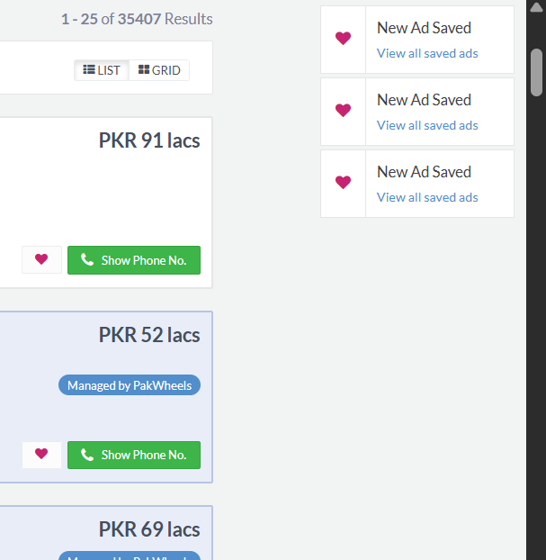
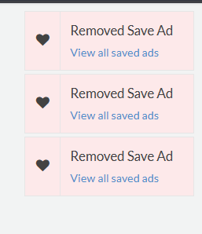
To implement a similar functioning, I created a class named as Buyer. Buyer is able to add a favorite car, remove favorite, send messages, and search car along with it they have a buyer ID, name, contact, and email attributes.
This class also involves aggregation when it comes to the market member of this class which has a datatype of Marketplace and involves composition by including the Car member.
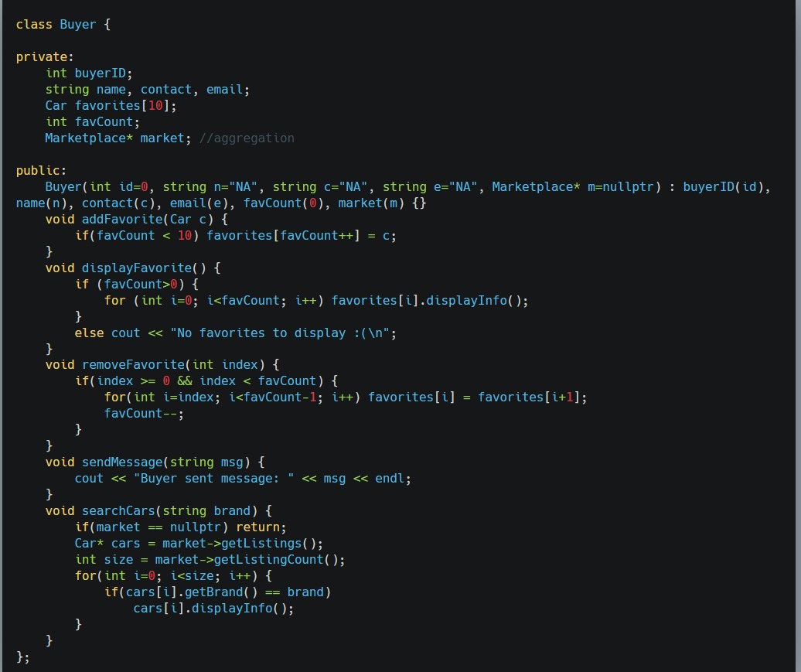

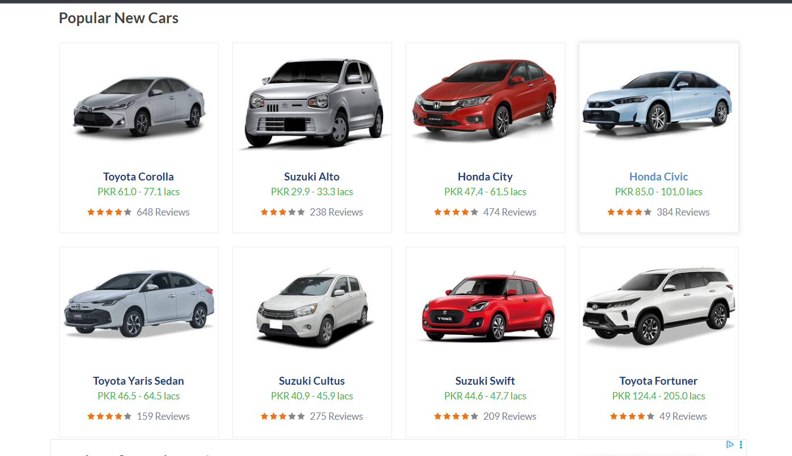
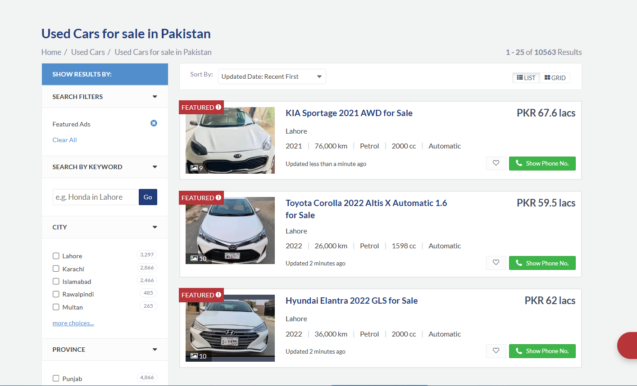
The PakWheels website lists the cars in this manner. To clone this part in my code I introduced a new class by the name of Listing. This class has multiple data attributes like listing ID, car object(composition), the date of the ad that is being posted, status, and the views.
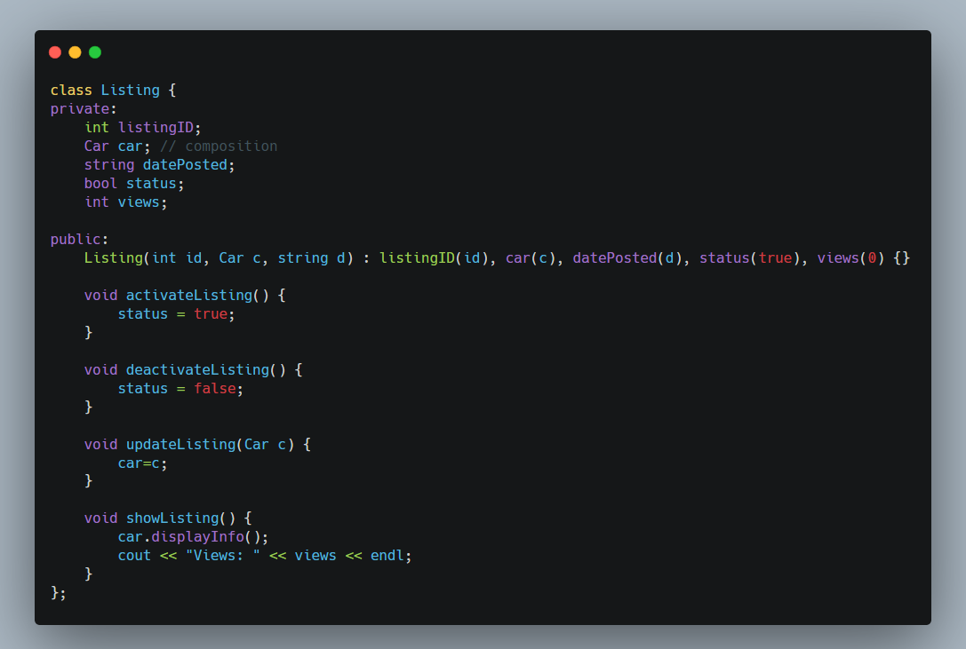
…………………………………………………………………………………………………………………………….
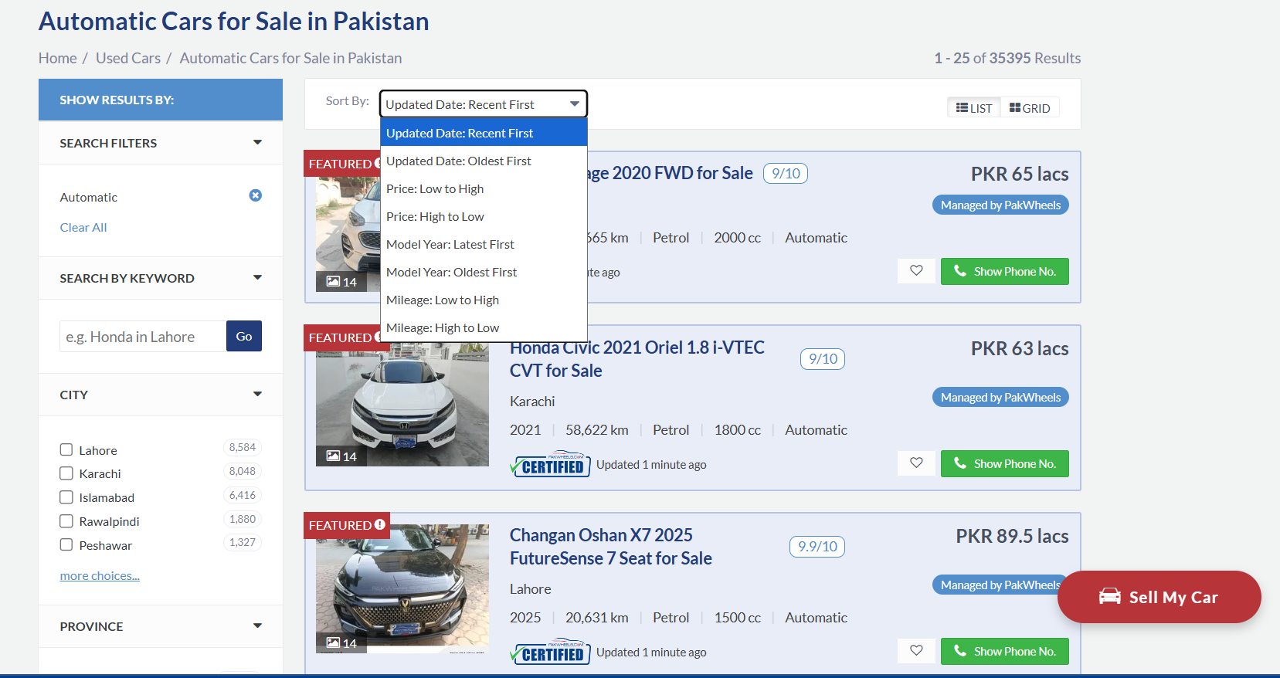

On the website there is an option to search and sort by filters, to implement this functionality in my code I introduced a new class by the name of SearchFilter. This class does the job searching, matching, and then applying the filter and then finally showing the result.
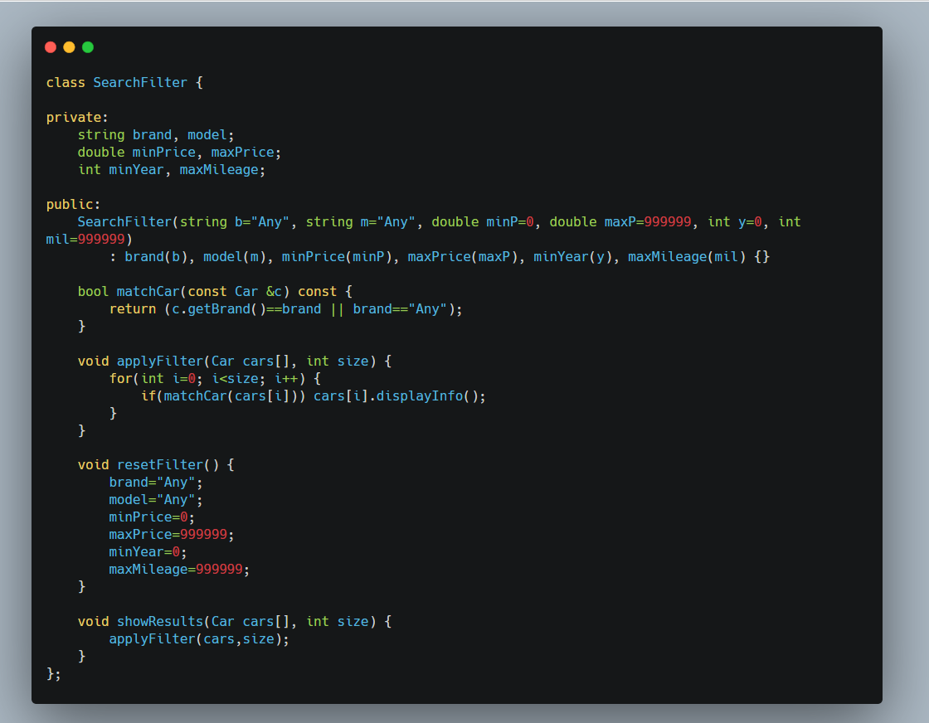

There are other classes in my code too like Payment, Message, and Admin. Together they all extend the functionality of this program.

